National University of Computer and Emerging Sciences

(Lahore campus)

Department of Computer Science

CS-401 Artificial Intelligence

Final Exam (Fall 2012)

Section B

Instructor:
Dr. Kashif Zafar

January 1, 2012

Total Marks: 100 Time Allowed: 180 min

- Exam is closed book and notes
- Calculator sharing is NOT allowed
- Make sure you have 6 number of pages

Roll No: __________ Name: _________________ Section: ______

Question | 1 | 2 | 3 | 4 | 5 | 6 | 7 | 8 | 9 | Total
Points | 11 | 16 | 16 | 8 | 8 | 8 | 15 | 8 | 10 | 100

Q1. a. Suppose we have a finite state machine defined by the following graph: (8)

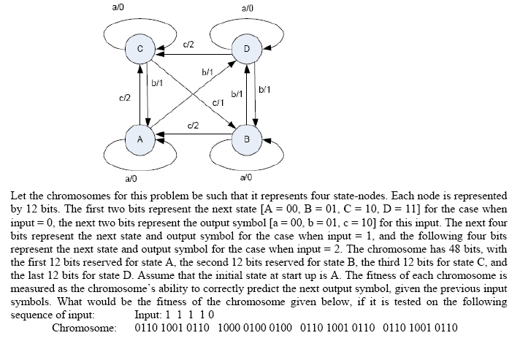

b. Using minimum number of bits, form a bit-string type chromosome comprising of
three genes x, y & z: where (3)

i) x = 3, y = 5, z = 1 (The range of values for each allele is 0-7)
ii) x = windy, y = cloudy, z = hot (There are 2 possible values for each allele)
iii) x = 128, y = 255, z = 32 (The range of values for each allele is 0-255)

Q2. a. Differentiate between Single Objective and Multi Objective Optimization problem using suitable example & graph. Implement ACO for route planning problem using 10x10 Grid manually and show the complete calculations for 2 iterations? Use 20% obstacles and starting cell is (3, 4) and goal state is (9, 9). (4+8)

b. Design the particle for the above problem using PSO algorithm and show the complete encoding and decoding for the above 10x10 Grid using an example. (4)

Q3. a. Draw architecture of a typical expert system given in the book by George F. Luger. Briefly define the three main types of expert systems? (8)

b. This question is related with Algorithm A*: (8)
The numbers in the graph below are the real distances between the nodes. The estimated distances to the goal node, G, are the following:
A: 18, B: 13, C: 8, D: 18, E: 5, F: 6
A is the start node.
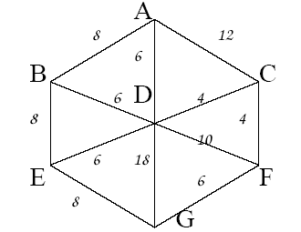

Do a search with algorithm A*. You can either show the successive open and closed list marked with the merit values for the nodes, or you can show the search tree, also with the values. Mark also in the tree the order in which the nodes are expanded.

Q4. a. Mini-max Search (5)

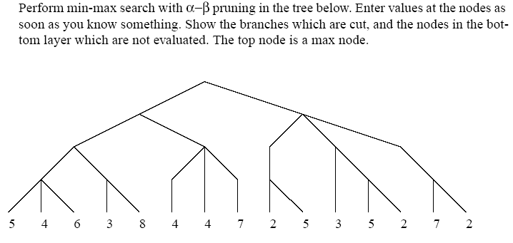

b. Suppose we have the following supervised data

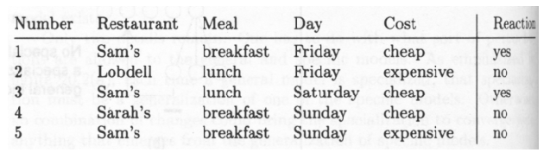

Suppose we have a chromosome: Sam – X – X - X
which represents the rule:
IF Restaurant = Sam, and Meal = X, and Day = X, and Cost = X ,
THEN Reaction = Yes ELSE Reaction = No
(where X is a general, don’t care value which matches every value)
What would be the fitness of the chromosome, if the fitness function is the number of data samples which are correctly classified by the chromosome. (3)

Q5. a. In Genetic Algorithm, a generation has 50 chromosomes, out of which 5 fittest ones are placed in the next generation without any competition from the offspring. The rest of the 45 chromosomes of the next generation are chosen from the pool of parents and offspring. Suppose 30 chromosomes of the offspring make it to the new generation. What is the generation gap and what is the elitism value. Duplicates are not allowed. (4)

b. Represent the following as a GP tree. (4)

Equation: Y = [2 / {1 + e-(λ*A)}] – 1
Where A = (W1 * X1 ) + (W2 * X2 ). The Wi, Xi, and λ are variables

Q6. a. Suppose there are 10 chromosomes with fitness as shown in table. What will be there selection probability according to proportionate and linear rank selection method: (5)

Chromosome No. Fitness Proportionate Linear Rank

A 50
B 25
C 25
D 100
E 75
F 125
G 250
H 110
I 140
J 100
Another Linear rank selection method can be to assign a probability ‘m’ to the fittest chromosome, and the probability ‘(1-m)*m’ to the second highest, and the probability ‘(1-m)*(1-m)*m’ to the third highest and so on.

b. If two parents are to be selected by tournament selection and the two randomly selected chromosomes sets are {A, D, H}, and {C, D, J}; which two chromosomes will be selected as parents. The fitness of chromosomes are A = 10, D = 18, H = 12, C = 5, J = 12. (3 marks)

Q7. a. Suppose, there are 9 rules in a fuzzy expert system, out of which 3 rules fire for a certain set of input conditions. The output parameter Y has the following membership values for these 3 rules:

Y’ = 0/100, 0.25/200, 0.5/300, 0.75/400, 1/500, 0.75/600, 0.5/700, 0.25/800,
0/900, 0/1000
Y’ = 0.5/100, 0.75/200, 0.75/300, 0.75/400, 1/500, 0.75/600, 0.5/700, 0.25/800,
0/900, 0/1000
Y’ = 0/100, 0/200, 0/300, 0.75/400, 0.75/500, 0.75/600, 0.5/700, 0/800, 0/900,
0/1000

What will be the unified value of the output? (4)

b. Find the intersection, union and complements of fuzzy sets A & B: (3)

A = {0/10, 0.6/20, 1/30, 1/40, 0.3/50, 0.1/60, 0/70, 0/80, 0.5/90, 1/100}

B = {1/10, 0.5/20, 0/30, 0/40, 0.1/50, 0.3/60, 1/70, 1/80, 0.6/90, 0/100}

c. Implement a “Fuzzy Logic Based Washing Machine” that automatically selects the operating time and saves electrical power wastage. Consider only one control variable: the operating time of the machine for each given load of clothes. The operating time is supposed to depend on two properties: how dirty the clothes are, and what type of dirtiness is present. Define the fuzzy sets, fuzzy rules and build the complete system. (8)

Q8. a. The current position vector of a particle xi is (3, 4). What could be its new position according to the formula of Particle Swarm Optimization algorithm? The best position of the particle is (25, 30) and the global best position is (15, 20). The range of the particles is limited in the grid of 100 x 100. Let c1 = c2 = 2 and let r1 and r2 be 0.5. Let w_{k} υ^{i} _{k} be 1. The formula is: (4)

b. Define, explain and apply the Back propagation algorithm to the following Artificial Neural Network. Your training example is:
E1: I1 = 1, I2 = 3, o=0; All weights are set to value 1 initially; learning rate is set to 0.2. Show the updated weight value after the training of the above example. (In the figure below, “in^2” means the square of the sum of the inputs.) (4 marks)

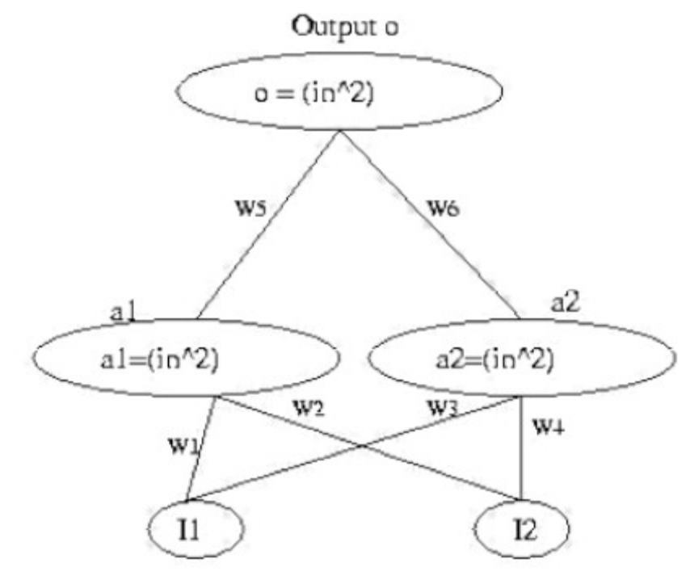

Q9. Implement algorithm A* for the 8 puzzle problem: The starting state and the goal state are given below. (10 marks)

2 | 8 | 3
1 | 6 | 4
7 |  | 5
1 | 2 | 3
8 |  | 4
7 | 6 | 5
Starting state Goal state

Good Luck!

